Project3- Monishankar and Satyaprakash Team

The Pie Shop Project

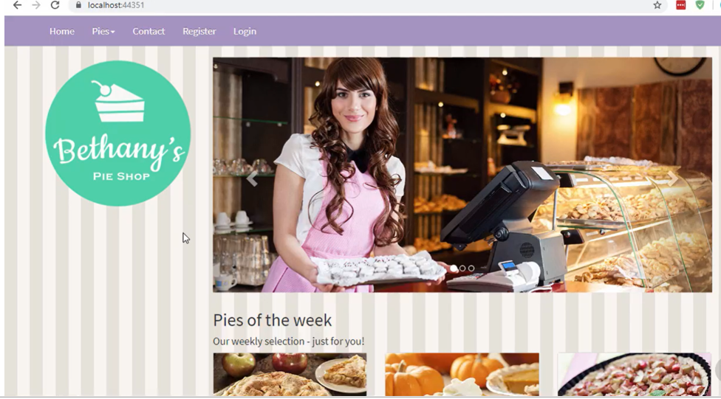

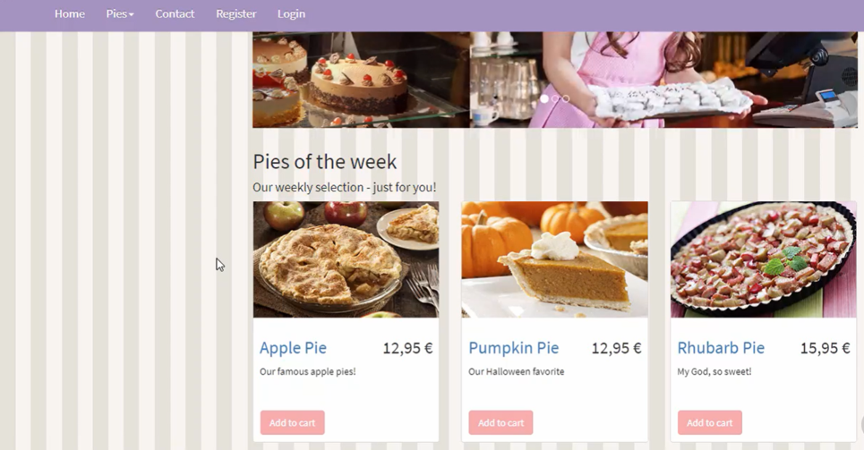

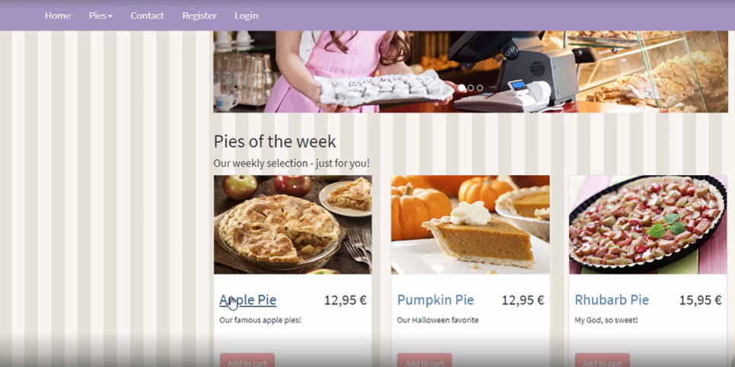

When I click on any name of the pie/cake I should be able to see the details of that product.

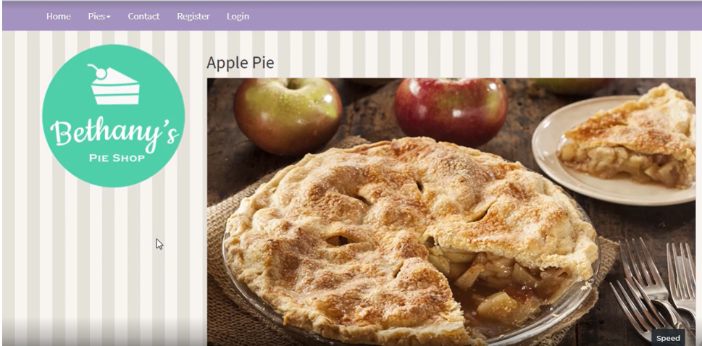

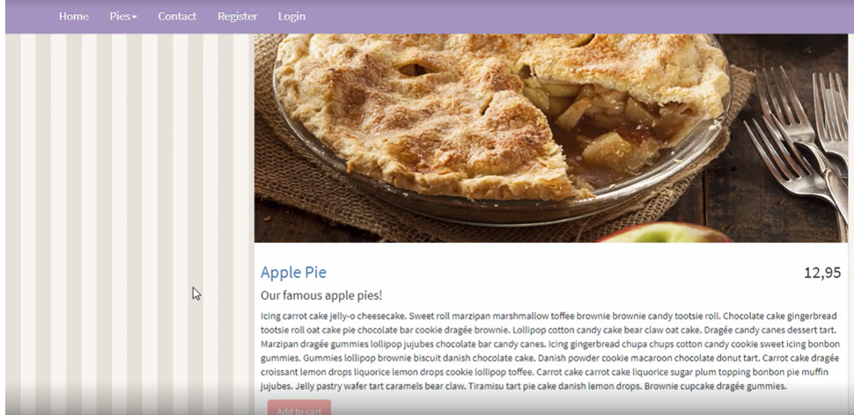

As per the above two screen shots

When I click on add to cart button, the following screen should be visible

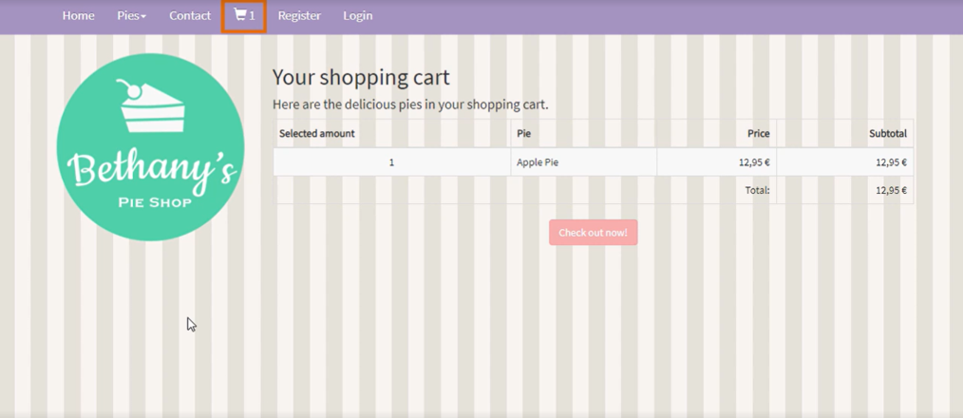

And also you should see the cart icon on navbar showing one item added to the cart.

On the nav bar there is a down carat symbol next to Pies menu item,which has the different categories. See the screen shot below.

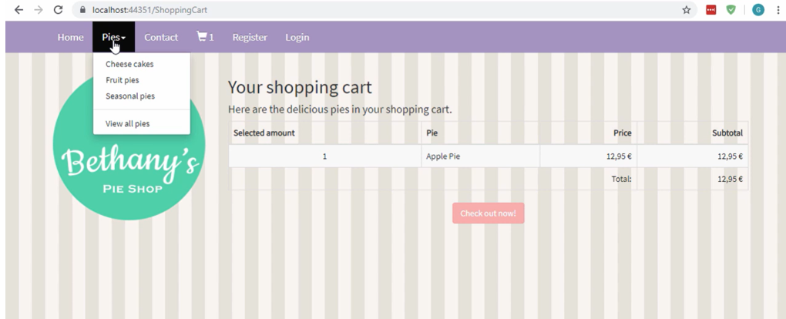

As per the selection under pies menu item you should see the list of those kind of pies. When you select ViewAllPies in the sub menu then all pies should be visible.

For example, if I select Cheese Cakes under pies menu the following screen shot is the output

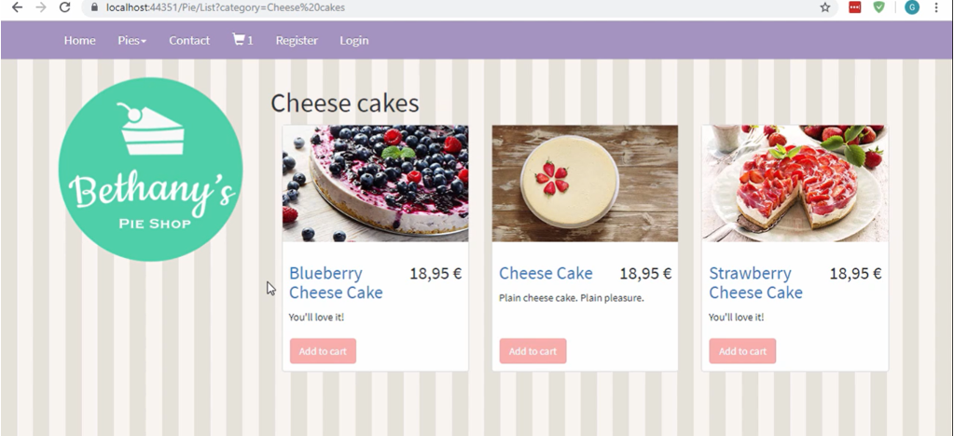

Same way screens should be visible for other menu items.

If I click on add cart button anywhere the item should be added to the shopping cart.

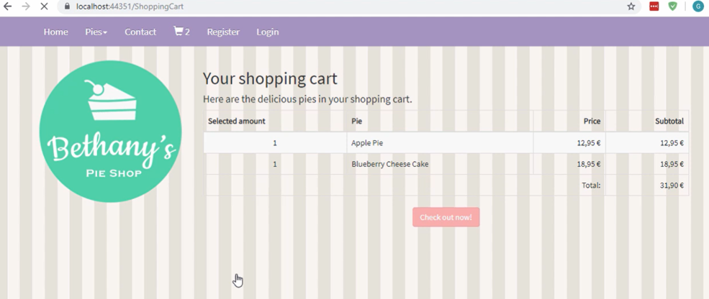

The shopping cart icon is now showing two as the count.

When I click on the Checkout now button,

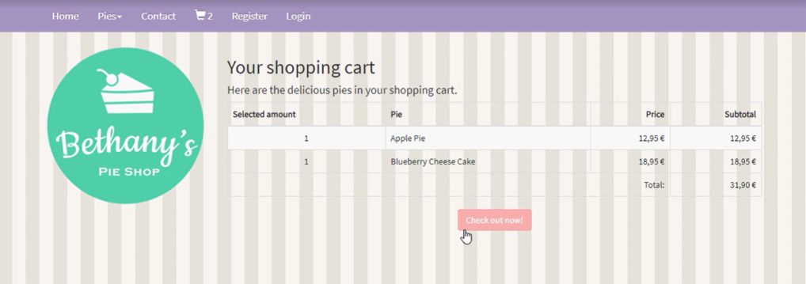

I should be redirected to login page if not logged in earlier as below

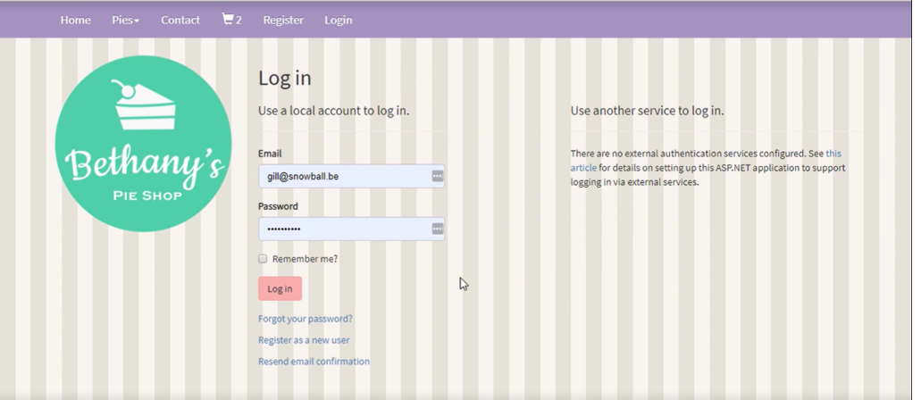

The user should be allowed to fill in the shipping details for the order to be delivered

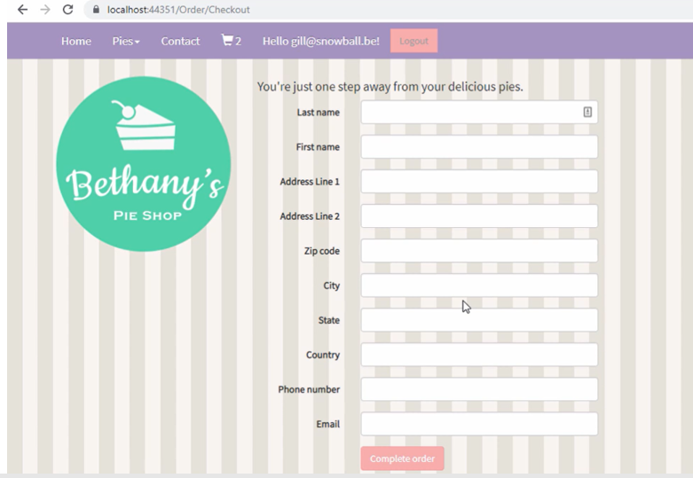

When you login as admin, only then, the admin should be allowed to add new pie categories, edit and delete pies from the database.